–

**Azure secure network Proposal**

**Build GDPR Secure VNet**

# **Vnet + DDOS + Bastion + VPN + Peering + Firewall**

PREPARED BY:

**Name**Role   
Ph  
Email

PREPARED FOR:

**TPCS**NY, USA  
[123-456-7890] | [123-456-9999]  
info@tpcs.com

**Version:** 1.0  
**Department:** Architect Department  
**Delivery:** End of Month

Simplilearn Pvt Ltd

Table of Contents

**Vnet + DDOS + Bastion + VPN + Peering + Firewall** 1

**1.** **The Project Summary** 3

**Option variations** 4

**2.** **The Proposed Azure Secure Network Solutions** 6

**Our Design Approach** 7

**Our Deployment Approach:** 7

**Our Proposed Azure Network Architecture Flow** 8

**Deployment and Build Plan** 8

**3.** **High Level Project Approach** 8

**Planning Phase** 9

**Build Phase** 9

**Deploy Phase** 9

**Stabilize Phase** 10

**4.** **Roles and Responsibilities** 10

**5.** **Project Communication Plan** 12

**6.** **Change Control/Request** 12

**7.** **Project Commercial** 12

# **The Project Summary**

|  |  |
| --- | --- |
| **Proposed Project Sponsor:** | A member of TPCS |
| **Proposed Project Board:** | Techpledge Network Architect  Techpledge Security Architect  TPCS Application Head  TPCS Development Team |
| **Proposed Project Manager:** | Mr. Project Manager |
| **Target start date:** | Next Week |
| **Target completion date:** | 8 Hr. |
| **Outline business case:** | |
| **Background & Rationale** | **Business Scenario** The Tyrell Crop wants to build a highly secured Globally distributed application. This application serves two types of content: images and dynamically rendered webpages. As their user base comes from across the globe this must be geographically redundant. The design demands that it should serve its users from the closest (lowest latency) location to them. For distinction, Tyrell Crop has decided that any URLs that match the pattern /images/* are served from a dedicated pool of VMs that are different from the rest of the web farm.  Design the Load Balancing architecture for Tyrell Crop.  For this sample do it in East US region, then you can select any other region and add those Application gateways on created Traffic manager. |
| **Objectives** |  |
| **Business Focus** |  |
| **Options** | **Option variations** **Baseline options:**  Recommendation: |
| **Benefits** | |  |  |  | | --- | --- | --- | |  |  |  | | **Cost** |  |  | | **All Services** |  |  | | **In-built Security** |  |  | | **Management** |  |  | | **Data Movement** |  |  | |
| **Outline Costs:** | For the **TPCS**, more than half of their may goes to implementing technologies and process to meet the compliance criteria of GDPR.  Azure has all the inbuild security features that we can configure without implementing any 3rd party costly devices and security tools. In this way, customer can save up to 60% of their cost by implementing services available in azure. |
| **Key Deliverables:** | * Create fully secure virtual networks in azure cloud. * Protection against Denial of defense attack. * Secure access of services from azure portal using Bastion. * Secure access of services of azure from on-premise using VPN. * Single control of traffic from One Single location i.e is Germany. |
| **Key Stakeholders** | * Network Architect * Security Consultant * TPCS Application Head * TPCS Development Team |
| **Key Resources** | * Network Engineer * Security Architect * Architect * PM. |
| **Considerations** | |
| **Exiting IT environment** | * Active Directory * VMware EXI/Hyper-V * Database 2016 * Web Server |

# **The Proposed Azure Secure Network Solutions**

### **Our Design Approach**

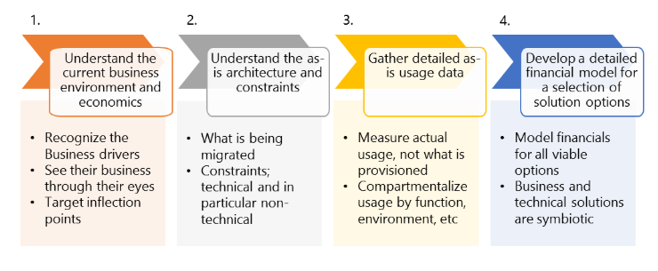

### **Our Deployment Approach:**

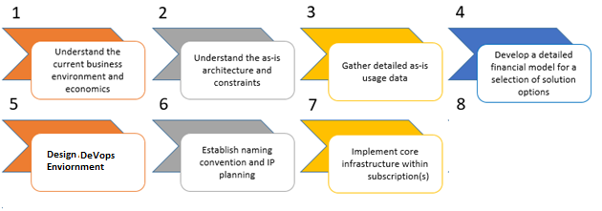

### **Our Proposed Azure Network Architecture Flow**

**Germany VNet Design**

**India VNet Design**

USA Vnet Design

### **Deployment and Build Plan**

|  |  |  |  |  |
| --- | --- | --- | --- | --- |
| **Milestone** | **Description** | **Duration** | **Start date** | **End date** |
| **M1** | Create Virtual Network for all three locations |  |  |  |
| **M2** | Define subnets as per plan |  |  |  |
| **M3** | Configure Security and Notification |  |  |  |
| **M4** | Configure bastion network in Azure |  |  |  |
| **M5** | Implement site to site VPN |  |  | T - 1 week |
| **M6** | Implement Point to Site VPN |  |  | T |
| **M7** | Configure Azure Policies to comply GDPR |  |  | T + 4 hours |
| **M8** | Configure Azure Network Security |  |  | T + 1 week |
| **M9** | Test the Communication |  |  | T + 2 weeks |
| **M10** | Handover the credential documents |  |  |  |

# **High Level Project Approach**

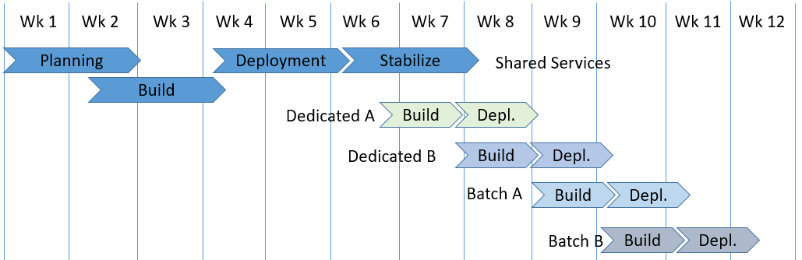

### **Planning Phase**

During the Planning phase, the team prepares the functional specification, works through the design and prepares design documents. Following the completion of this phase, the team moves forward to begin construction of the solution in the Build phase

.

* Build initial Architecture
* Build initial Implementation blueprints and planning for dedicated customer environments for implementation of secure network.
* Setup initial project planning, team structure, tracking, and risk management
* Validate and finalize Architectural blueprint
* Validate and finalize implementation blueprint.
* Finalize connection of ports open for networks.
* Establish project organization and allocate resources
* Identify 3rd party dependencies and engage these 3rd parties.
* Define implementation procedure verification criteria
* Define platform acceptance tests on core components to support coexistence

### **Build Phase**

During the Build phase, the team builds the core infrastructure and prepares the procedures and tools required for deployment Completion of this phase marks the transition to the Deployment phase.

The following are typical activities during this phase:

* Preparation of procedures to build core platform building blocks
* Preparation of procedures for Integrated with secure network with existing applications.
* Execution of functional tests as defined in deployment procedure.
* Execution of functional tests as determined in the definition of platform acceptance test on core components to support coexistence
* Validation and finalisation of procedures to build core platform building blocks
* Validation and finalisation of procedures for network implementation.
* Build platform core components – Vnet, Subnet, DDOS, Bastion, VPN, Firewall etc.

### **Deploy Phase**

During the Deploy the virtual network use to provide secure connectivity option both from portal and on-premises.

The following typical activities could be identified:

* Configure 3 Azure Virtual networks for Germany, Singapore and India.
* Configure Subnets in respective virtual networks.
* Configure Bastion Subnet in Germany Virtual network.
* Configure Vnet Peering between Germany and Singapore and Germany & India.
* Configure Gateway Subnet for Germany.
* Provision VPN Services in Germany virtual network.
* Configure local gateway for Germany, Singapore and India.
* Configure Site-Site VPN from Azure to Germany, Azure to Singapore and Azure to India.
* Generate VPN route certificate and VPN client certificate using Powershell.
* Configure these certificate on Azure point to site configuration.
* Enable DDOS protection on Germany Vnet.
* For, UAT Purpose, Create Servers in Frontend Subnet of Germany and Singapore. And Access it using bastion and VPN.

### **Stabilize Phase**

During the Stabilize phase, the team focuses on resolving issues and bugs.

The following typical activities could be identified:

* Stabilize the environment and identify any issues. These issues will be triaged, prioritized and resolved.

# **Roles and Responsibilities**

|  |  |
| --- | --- |
| **Role** | **Responsibilities** |
| Program Manager | Makes key project decisions, assists in escalating unresolved issues to the Executive Steering Committee, and clears project roadblocks from a customer perspective. |
| Project Manager | Primary point of contact for team Responsible for managing and coordinating the overall project Responsible for resource allocation, risk management, project priorities, and communication to executive management Manages day-to-day activities of the project Coordinates the activities of the team to deliver deliverables according to the project schedule |
| Technical Leader | Keeps technical oversight and responsible for long term technical alignment Advises program manager on technical decisions Advises program manager on deliverables sign off Primary technical point of contact for the team that is responsible for technical architecture and code deliverables Responsible for overall architecture and technical decisions as well as technical success. First level of quality control Coordinates technical status meetings Oversees all technical delivery streams from a technical perspective |
| DePloyment Lead(s) | Responsible for end to end planning DevOps Process Implementation . Responsible for identification of dependencies customer contact Performs and lead actual Deployment , if needed supported by SMEs |
| Subject Matter Expert(s) | Specific component related technical expertise Responsible for implementation of any infrastructure and application aspects required to support the transformation within the current local environment. Responsible for the build of target environment(s)Responsible for implementation of migration scripts and procedures |

# **Project Communication Plan**

|  |  |  |
| --- | --- | --- |
| Daily Report | Email | All Stakeholders |
| Weekly Report | Email and Project Plan | Only to Management |
| Adhoc Report | Email, | Respective Stakeholders |

# **Change Control/Request**

Customer has to raise CR.

CR will reviewed and approved by program manager

# **Project Commercial**

|  |  |
| --- | --- |
| Cost Head | Commercial |
|  |  |
|  |  |
|  |  |